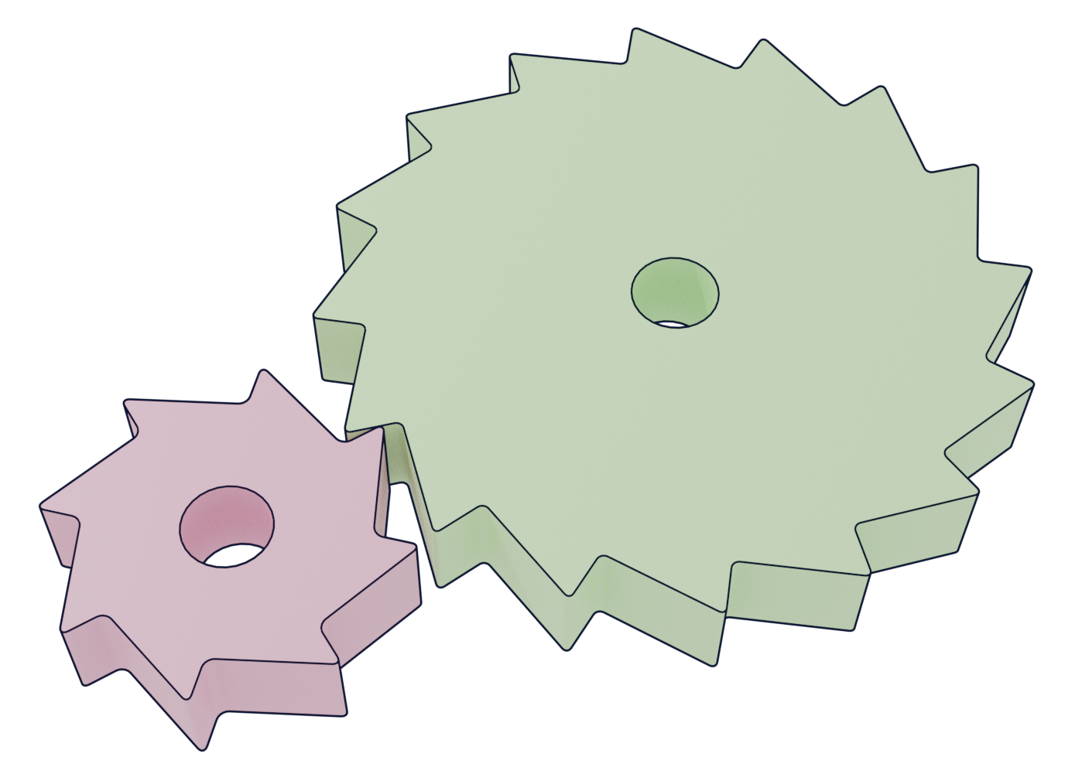
Thickness of gear: 10mm
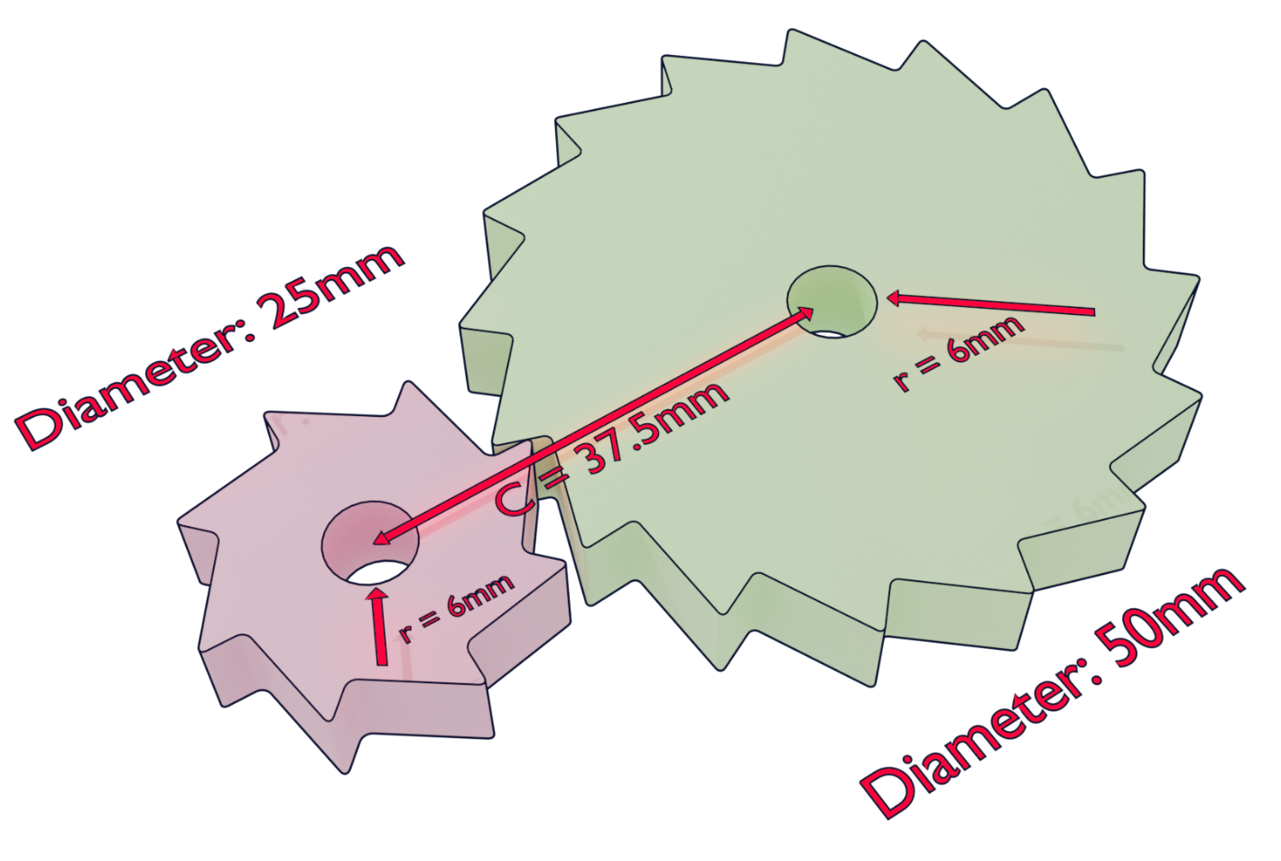
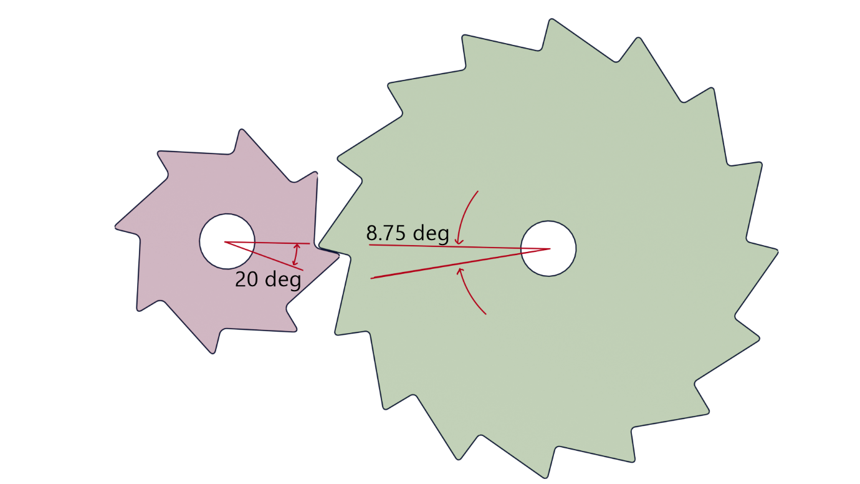
Notes:
Pink, inner circle without gearing is 0.85% smaller than the outer radius (where the gear tip is) Pink, is half the size of green.
Pink is 8 tooth, Green is 16 tooth.
Pink, if you imagine a triangle (perfect and isosceles) and push the top by 20 deg, this is the value. Push over by 20 deg (see image below)
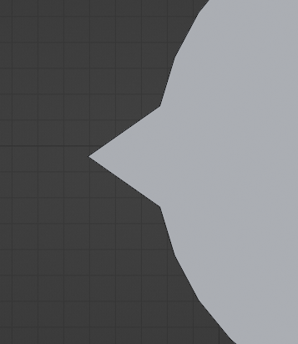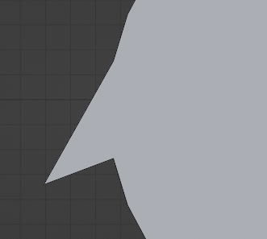
Pink and green have a bevelled edge of 0.05mm

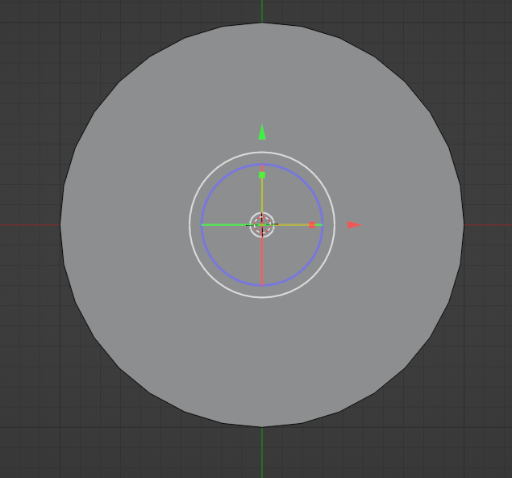
Starting circle
This is big gear, it will have 16 teeth.
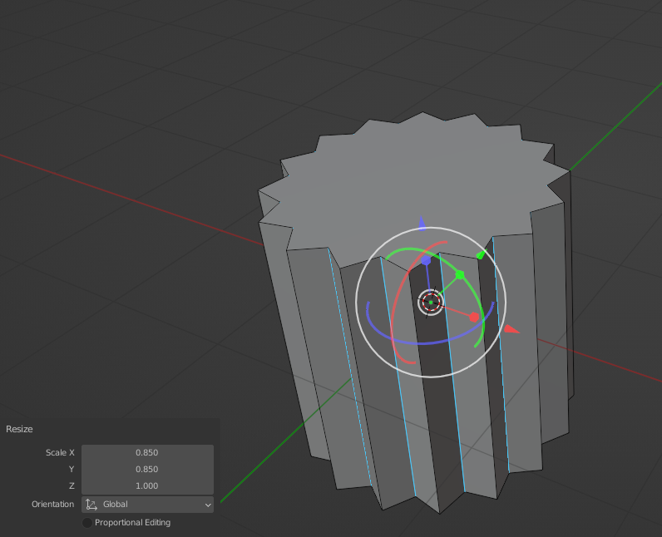
The inner circle is 0.85% smaller than the outer circle.
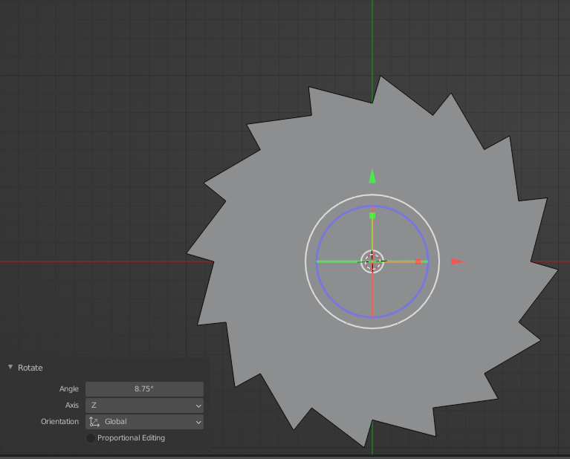
For the bigger circle, the teeth are shifted by an angle of 8.75 deg. (see images given on page 3)
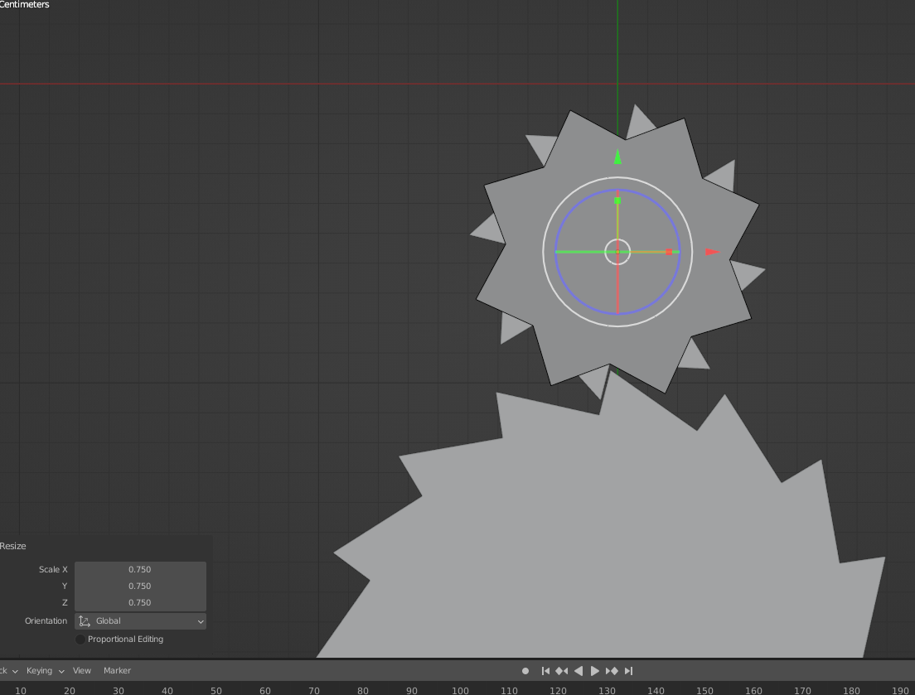
The smaller gear is half the size of the big gear and has 8 teeth.
It is rotated at 20 deg.
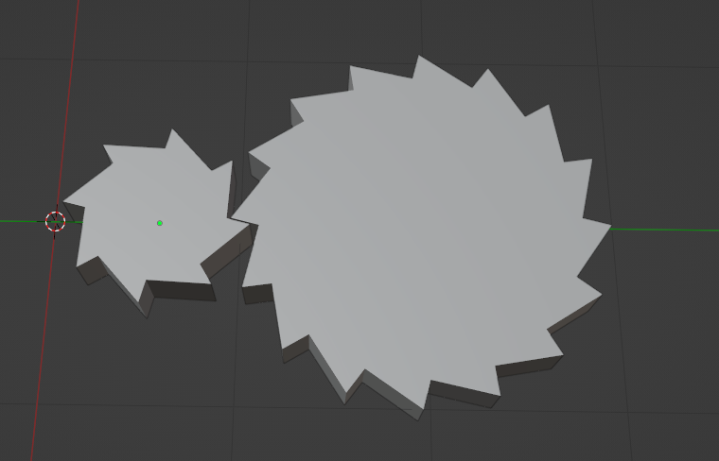
Smaller gear angle is 20deg
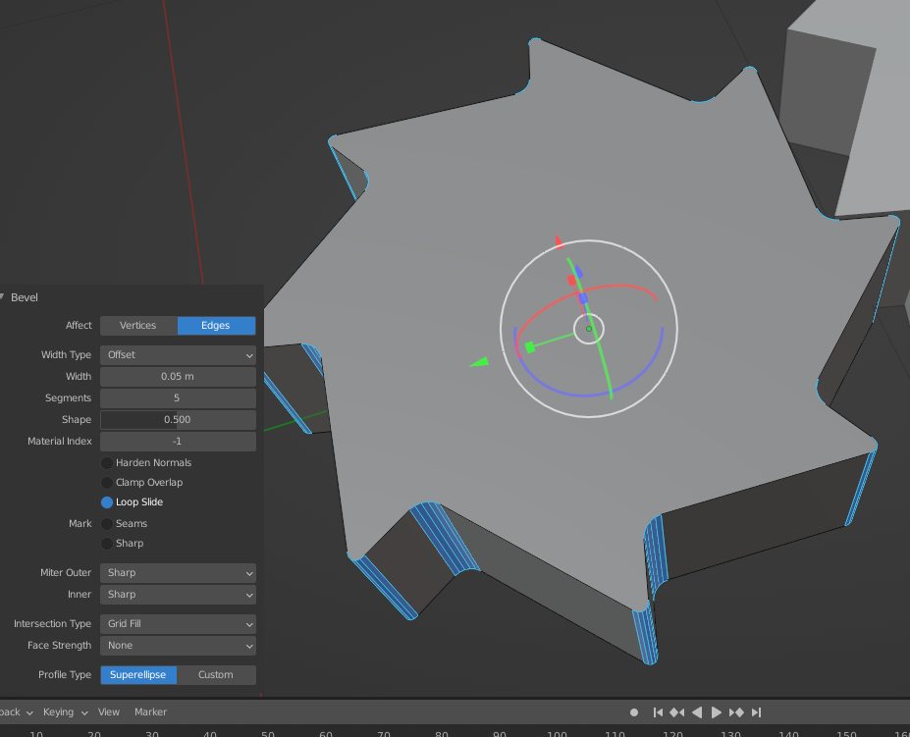
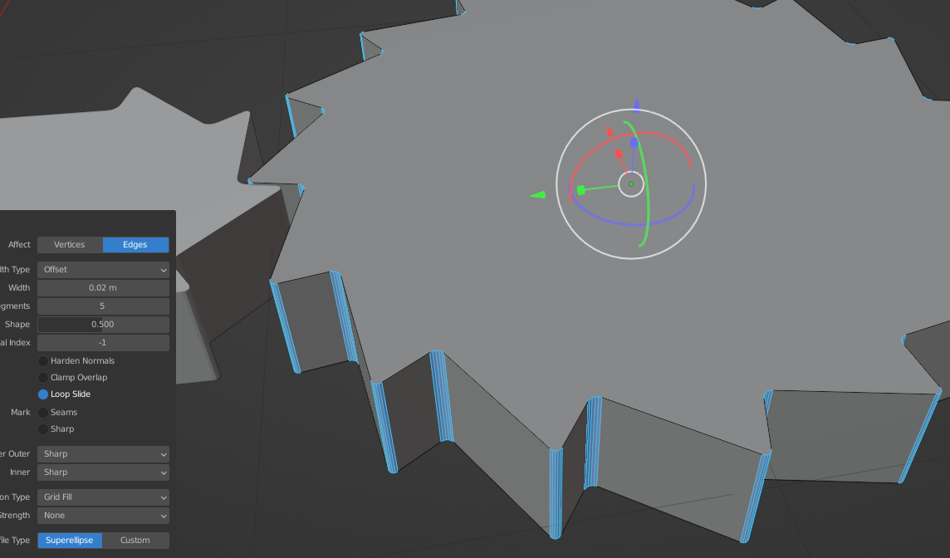
Bevelled edges of 0.05mm

